

Project Report

Cloud Kitchen **-** GrubKing



Contents

Case Study

1. Definition of the Problem 3
2. Requirement Analysis 3
3. Design Phase 3
4. Architecture of Website 4
5. Evaluation/Testing 4
6. Project Tracking and Monitoring Activities 5
7. Documentation Section 6
8. **Source Code** 17
9. **User Guide** 17

## Project Guide



# Case Study

Eating home cooking foods can sometimes be a luxury or even a time-consuming job considering the number of preparations. If a person exhausted after a hard working day or a sick person and could not cook, ordering online dishes could be a good alternative. Perhaps, a group of people suddenly visited your home and didn't have time or not available raw materials to cook an elaborate meal quickly for so many people. Ordering online will be an easy way.

Besides these things, there are many other cases where online feeding will be more reasonable than cooking at home.

According to a recent study conducted abroad, there may be a script that in 2030, most of the currently cooking meals at home are ordered online and delivered from Chinese restaurants or kitchen center. When restaurants and kitchens cooperate with online services to form collaboration, those services are called clouds (Clouds Kitchen).

### Proposed Solution

So the GrubKing website is created to help those who do not have time to cook or don't know can easily put daily dishes quickly and conveniently, which is the reason grubking create.

The suggested website for online dishes will be named Grubking and its goal will be allowing people to look through the online restaurant menu and place food online.

# Definition of the Problem

After reading the project specifications, the developer states the scope of the project very briefly. This is referred to as the problem definition.

For example, in the case of **GrubKing** portal, queries of various staff members can be one or all of the following:

1. How many dishes will be displayed on the order page at a time?
2. How many dishes will be displayed in different dining hours?
3. Where will the prices and addresses of the restaurant's restaurant will be displayed for users?
4. Will users contact the restaurant or restaurant they like to be displayed on the website?
5. Will the cafes or restaurant cooperate with Grubking contact the website to exchange work or not?

After consulting several IT companies and considering the budget constraints, the management of **GrubKing** has decided to launch the Web application as a Single Page Responsive Web application. Hence, the project will use HTML5, CSS3, JavaScript , JSON & text document, and Bootstrap 4 libraries from getbootstrap.com, jQuery plugins and Notepad++, or other HTML editors. Also, the site will be tested on popular browsers and mobile emulator software.

## Project Guide



# Requirement Analysis

This stage includes the following:

➢ List of inputs for the system

* Input provided by the customer:
* Enter the existing system

➢ List of expected outputs from the system

* Output from the existing system
* The process of participating in the application
* Expected delivery date
* List of delivery

➢ Overview of system-related processes

* Is the interface of breakfast, lunch, dinner, snacks and drinks. Help users have more options in choosing.
* Order and pay easily, conveniently and quickly.
* Customer acceptance criteria for the project

➢ Hardware and software needed to implement the project

Hardware requirements:

• Intel Core i3 / i5 Processor or Higher

• 8 GB RAM or Above

• Color SVGA

• 500 GB Hard Disk Space

• Mouse & Keyboard

### 

## Project Guide



**Software Requirements:**

* Windows 8, 10 or higher
* Browser supports HTML5 and JavaScript
* Bootstrap Library 3.3 from getbootstrap.com, jQuery and Coffeecup plugins, Notepad ++ or other HTML edits
* Interface (Frontend): HTML5, CSS3, Bootstrap, JavaScript, JQuery, AngularJS, Angular9 (Optional), XML
* Data (data store): JSON Files or TXT Files

### Scope of the work:

This electronic portal will be a visually responsive and attractive website for individuals to use. This portal will be designed to allow users to browse and select food items to be delivered. Payment and delivery functions are outside the scope of the project.

* Home for grubking portal will continue to display menu options to register / log in, with search and filter bars, order, pay, introduce and contact us.
* Register / log will lead to appropriate pages where users can register or log in if registered.
* Menu will display images of dishes, description of dishes, where the restaurant is made and some related information
* About Us and Contact Us should contain some relevant information.
* The user can view and visit the links of their favorite stores or restaurants.

# Design Phase

### Designing the GUI Standards

For grubking portals, multiple monitors must be created and linked together. Each of this screen needs a consistent look for the appearance and theme. Font styles, color labels, designs and interfaces of commands, the appearance of the title and footer, and the design and size of the controls, such as checkboxes or right text boxes Be consistent through all forms.

In case of grubking portal, the module can be for:

* + Registration
  + Login
  + Appointment

### Assigning and Monitoring Tasks

You are expected to fill in the task table as in the 'SWD / Form 7' document given in

The documentation of this project form.

You should fill in the final checklist in the 'SWD / Form 8' document given in the document

Part of this project form.

## Project Guide

# Architecture of Website

Figure 1.1 displays the application architecture.

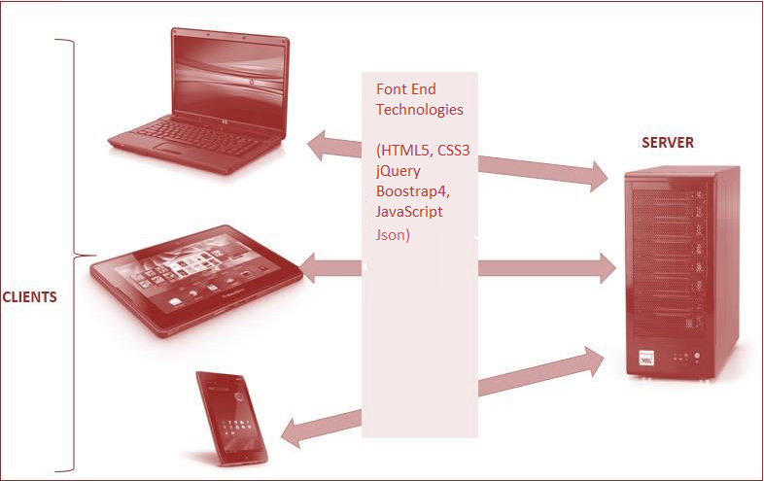

### Figure 1.1: Application Architecture

## Project Guide



### Site Map

The sample site map illustrates the navigation flow of the objects on the Web portal.

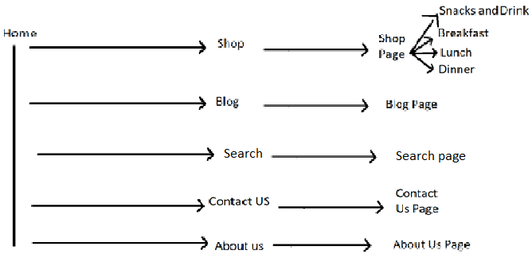

# Evaluation/Testing

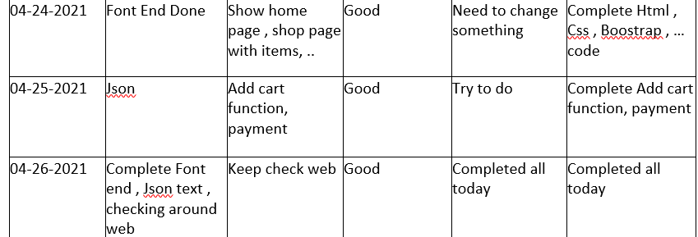

# Documentation Section

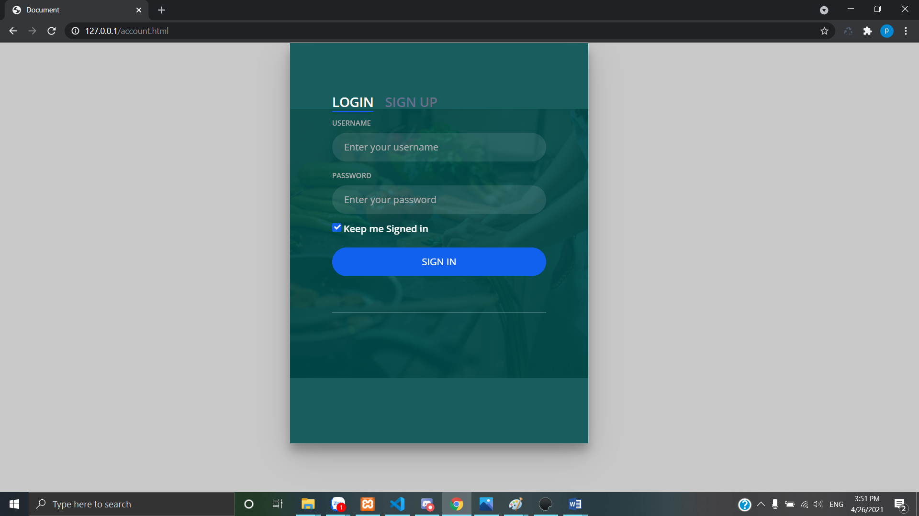

# Source Code

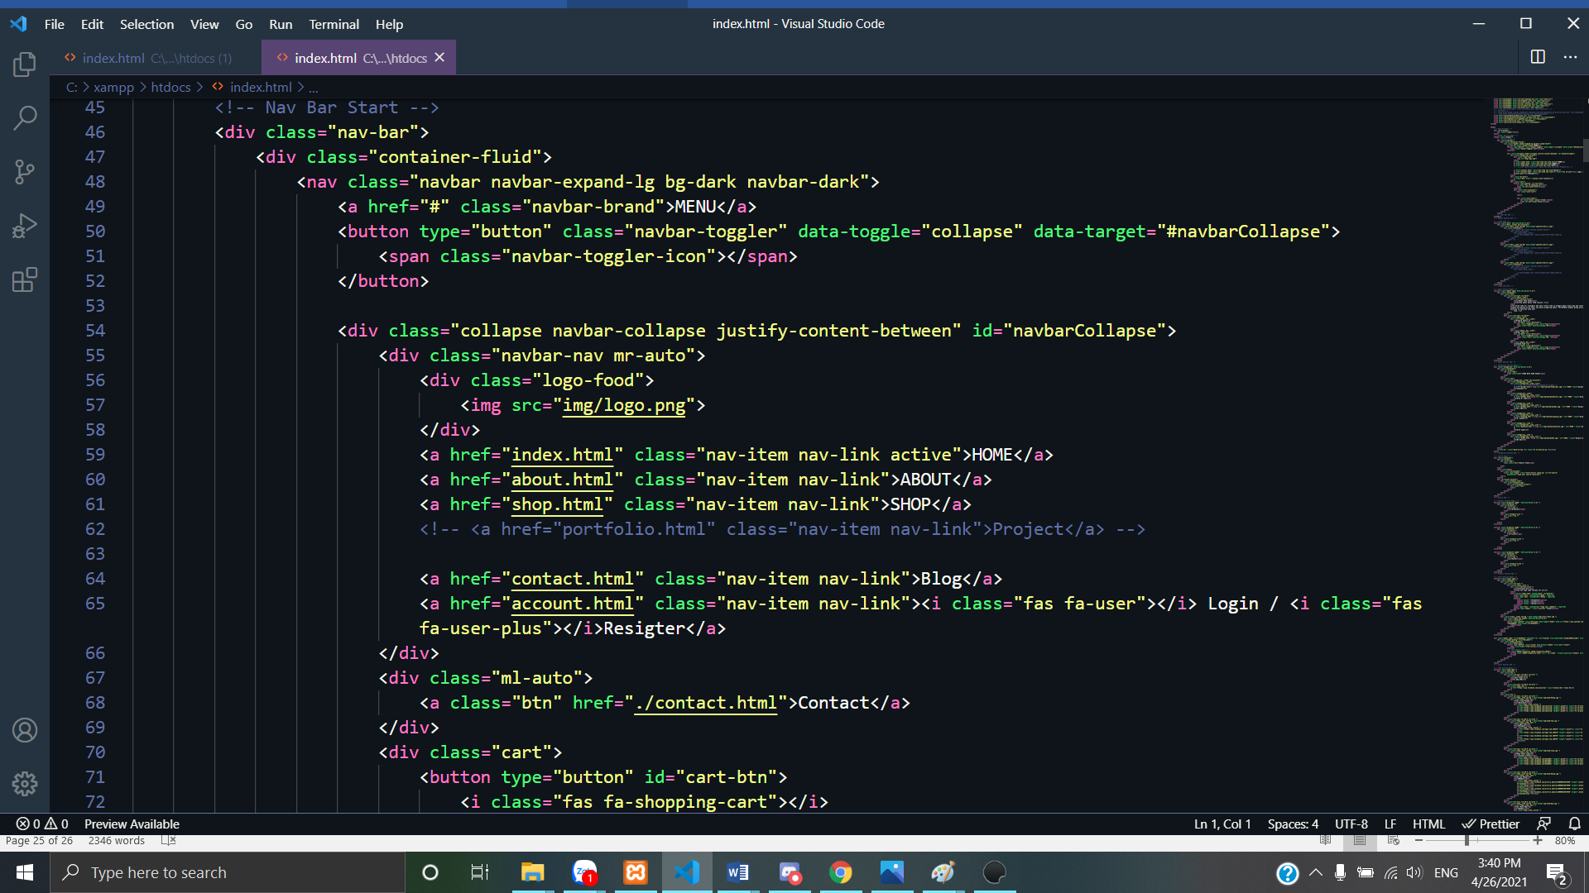

# User Guide

The Website will be hosted on a local Web server and will be tested on all latest and popular browsers such as IE, Opera, and Chrome. The requirements on the client machine include Pentium 4 or higher processor, 1 GB or higher RAM, and a compatible browser to view the Website.

Website url: <https://github.com/canxivtp2511/GRUBKING>

*~~ End ~~*